When we “process” each 3D model in the HOTS pipeline, we perform a standardized series of geometric transformations and format conversions so that every mesh:
- Is centered at the origin
- Faces a consistent “up” direction
- Fits within a known size range
- Uses the correct units and file format
- Has its key metadata (bounding box, diameter) recorded

Concretely, for each input OBJ mesh we:
- Load & prepare geometry
  - Read the triangle mesh from disk (using Open3D)
  - Compute per-vertex normals so lighting and downstream operations work correctly
- Centering
  - Compute the mesh’s geometric center
  - Translate all vertices by the negative of that center, moving the mesh so its centroid is at (0,0,0)
    - simple but powerful normalization step (especially when dealing with AI-generated models whose coordinate frames can be completely arbitrary)
    - Instead of “floating” randomly in the x,y,z coordinate system, we make sure all of our objects have the exact same center (0,0,0 in this case) so we translate them from wherever they are in the environment to that point.
- Axis‐alignment
  - Apply a fixed rotation matrix (configured via ROTATION_X/Y/Z in config.py)
    - Only necessary if the user wants to use a specific coordinate system
- Uniform scaling
  - Measure the mesh’s extent along its longest axis
  - Compute a scale factor so that this maximum dimension matches a pre‐defined target (which can vary by object category) found in config.py
  - Scale all vertices by that factor, guaranteeing every model fits within the same size envelope
- Unit conversion & format output
  - For the Linemod-style output: multiply vertex coordinates by 1000 to convert meters→millimeters
  - Export the result as a PLY file (instead of OBJ) so downstream tools expect the right format and units
- Metadata extraction
  - Compute the axis‐aligned bounding box of the processed mesh
  - Compute its diameter (the longest distance between any two points)
  - Write these values into models_info.yml under the object’s ID, so the pose-estimator knows the real-world size
- Cleanup
  - Remove any temporary files created during OBJ→PLY conversion

Definitions:
Triangle mesh (Open3D): A way of representing a 3D object by connecting points (vertices) with flat, three-sided polygons (triangles). In Open3D, meshes let us load, display, and manipulate 3D shapes efficiently.
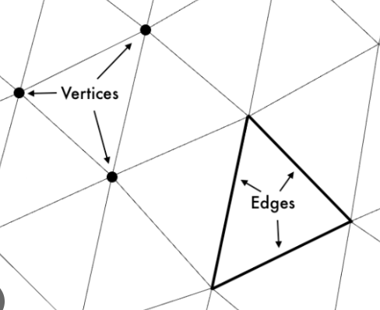
Vertex (plural: vertices): A single point in 3D space, defined by its X, Y, and Z coordinates. You can think of vertices as the “corners” of the triangles in a mesh.
Triangle: A flat surface formed by three vertices joined by straight edges. Many triangles glued together approximate the curved or complex surfaces of real objects.
Per-vertex normals: A little arrow (vector) attached to each vertex that points “outward” from the surface. Normals tell lighting and rendering algorithms which way the surface is facing, so the object looks smooth and shaded correctly.
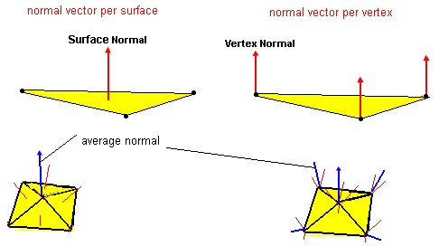
Mesh’s geometric center: The average position of all the mesh’s vertices. If you imagine balancing a physical model on your finger, you’d place it at the geometric center so it doesn’t tip over.
Centroid: Another word for the geometric center. It’s the “middle point” of all the vertices taken together.
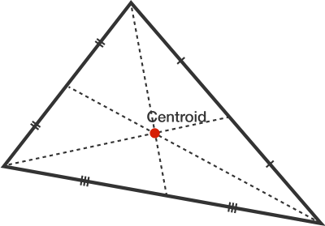
Rotation matrix: A 3×3 grid of numbers that tells you how to spin or turn points around the X, Y, and Z axes. Multiplying each vertex by this matrix rotates the entire mesh to a consistent orientation.
Mesh’s extent: The size of the mesh along one direction, specifically, the distance between its minimum and maximum vertices along an axis (e.g., how tall, wide, or deep it is). We use this to decide how much to scale the mesh so it fits our standardized size.
OBJ (Wavefront .obj): A common 3D file format that lists a mesh’s vertices, normals, and faces in plain text. OBJ is easy to read and edit but doesn’t enforce units (meters vs. millimeters).
PLY (Polygon .ply): Another 3D file format that can store vertices, normals, faces, and extra per-vertex or per-face data. PLY files often include a header specifying the units (e.g., millimeters), making them safer for pipelines that need consistent real-world dimensions.
Bounding box: The smallest rectangular box (aligned with the axes) that completely encloses the mesh. It’s like drawing a tight-fitting box around the object to know its overall footprint in X, Y, and Z. We record its size so downstream tasks know the object’s real-world dimensions.
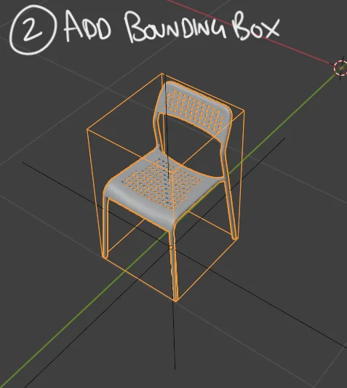

Computing the centroid to (0,0,0):
V = [
(2, 3, 1),
(4, 5, 1),
(3, 6, 2),
(1, 4, 1)
]
- Compute the centroid (geometric center):
  - c=(mean(x), mean(y), (mean(z))​)=(2.5,4.5,1.25)
- Center the mesh: subtract c from every vertex:
  - V’ = V - c = [(−0.5,−1.5,−0.25),(1.5, 0.5,−0.25),(0.5, 1.5, 0.75),(−1.5,−0.5,−0.25)]
  - Now the object “lives” around (0,0,0)

